Summary of CDR/CPR Modelling:

- Problem to solve
We are given a snapshot of the current portfolio and we are to forecast the balances into each of the four statuses (‘Current’, ‘Delinquent’, ‘Prepaid’, ‘Defaulted’). And from the forecast balances we can calculate the SMM for default and prepay and hence CDR and CPR curve.

- Data Cleaning
As the data given contains information that is redundant and misleading, we need to clean the data before analysis. Data cleaning is the crucial part of forecasting the balances. The portfolio consists of all current loans in the portfolio with following loan status as the table below
Current | Paid Off | Charged Off | 30 – 59 Days Delinquent | Late (16 – 29 DPD) | 60 – 89 Days Delinquent | >= 90 Days Delinquent | Defaulted
276553 | 173077 | 105062 | 4561 | 3491 | 4571 | 4189 | 13

We will discard the loans that are paid off and defaulted because those loans will stay defaulted and paid off forever and will offer no use in forecasting CDR and CPR.
The loans count by term is as below:
Term | 12 | 18 | 24 | 30 | 36 | 42 | 48 | 54 | 60
Count | 12174 | 4509 | 59343 | 4246 | 253616 | 6579 | 172863 | 924 | 57263

We will focus do our analysis on the loans with term of 36 months as those loans are most representative for the portfolio.
Data that is given contains:
- Loan-level specifics: Original Loan Balance, Grade, Payment to Income, Origination Date, etc
- Current Loan Balance
- Loan-Level Monthly Payment String: e.g ‘CCC12D’
- Macro-Economic Data

- Define Loan Status
We will define 4 statuses for the loans: Current, Delinquent, Prepaid And Defaulted. A loan can be in only one status in each month. So the decomposition of the loans becomes:
In our analysis | Original Data | Count
Current | Current | 276553
Delinquent | 30 - 59 Days Delinquent | 16812
Delinquent | Late (16 - 29 DPD) | 16812
Delinquent | 60 - 89 Days Delinquent | 16812
Delinquent | >= 90 Days Delinquent | 16812

In total we have 293365 loans.

- Cleaning loans:
- We will discard those loans that the payment string start with ‘O’, i.e. ‘Charged Off’.
- For 1 month delinquent loans, we categorize them as ‘Current’ as one month payment missing can happen due to many irresistible reasons such as people can go on vacation and forget the payment. And from the loan patterns we can see a lot of loans with payment string ‘C1C’ which confirms that people may forget one month payment and recover back to Current Status
- For 2 month or more delinquent loans, we consider them as serious delinquent and categorize them as ‘Delinquent’.

- Stack up Loans:
Since loan age will be an important factor in forecasting loan status and loan balances, we need to stack up each of the loans and create one age variable.
For example, an original loan with the following variables:
Original Loan Balance | Current Loan Balance | Loan Status | Term | Age | Grade | Interest Rate | Pre-Loan DTI | Payment-To-Income | Original FICO | Housing Status | Payment String
1000 | 800 | Current | 36 | 3 | A | 24 | 0.2 | 0.2 | 700 | Rent | CCC

Will become
Original Loan Balance | Current Loan Balance | Loan Status | Term | Age | Grade | Interest Rate | Pre-Loan DTI | Payment-To-Income | Original FICO | Housing Status | Age | Status
1000 | 800 | Current | 36 | 3 | A | 24 | 0.2 | 0.2 | 700 | Rent | 1 | C
1000 | 800 | Current | 36 | 3 | A | 24 | 0.2 | 0.2 | 700 | Rent | 2 | C
1000 | 800 | Current | 36 | 3 | A | 24 | 0.2 | 0.2 | 700 | Rent | 3 | C

After the stacking up for each loan, we will have 3.3 million entries.

- Bucketize Loan-specific numerical and categorical variables:
Standard practice is to transform numerical values to categories. Reason of doing so is by converting numerical values to categorical values, we could clearly see the trend effects to the probability from each variable and make the buckets more meaningful.
Our buckets selection is as below:
- Original Loan Balance:
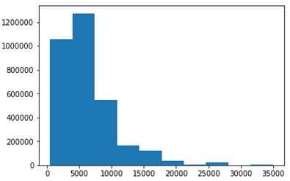
Buckets are [0, 8000), [8000, 15000), [15000, 20000), [20000+)

- Interest Rates:
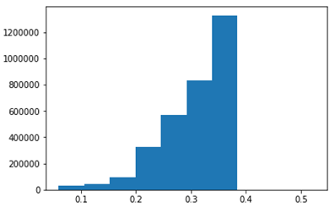
Buckets are [0,0.2), [0.2,0.25), [0.25,0.3), [0.3,0.35), [0.35+)

- Payment To income:
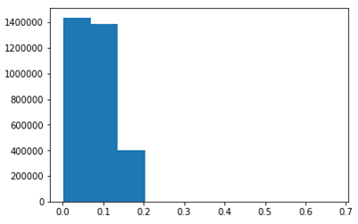
Buckets are [0,0.05), [0.05,0.1), [0.1,0.15), [0.15+)

- Original FICO Score:
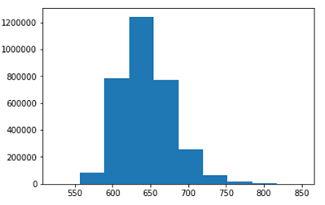
Buckets are [0, 600), [600, 650), [650, 700) [700, 750), [750+)

- Grade

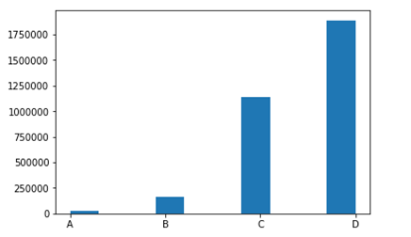
As there are not too many loans with grade A and grade B we choose buckets as [A&B], [C], [D].

- Housing Status
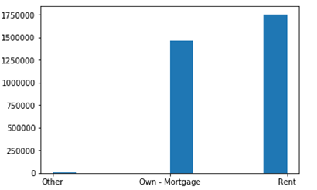
Even loans with ‘Other’ are minimal, we consider them an important category and we choose buckets as [‘Other’], [‘Own-Mortgage’], [‘Rent’].

- Age:
For age variable, we need to use single value buckets because when we do forecasting, our matrix will evolve each period by 1 and if we have age range buckets that is longer than 1, we will need to track the loan-level age and reorganize our regression data into different age buckets. And also the first 24 months are more important to track the portfolio balances we decide to use age buckets as below:
[1], [2], [3], …, [23], [24 and above].

- Matching Macro-Economic Variables
We choose to use daily unemployment rate, 3 year swap rates as the macro-economic variables.
Before merging the macro-economic variables, we will need to define a Date variable to match with the daily Macro-economic data. Since the payment string history is monthly, we will need to use the same day in each month to denote the payment date. If the exact date does not exist in next month, we will use the previous available date.
For example, a loan that is originated on Jan 29th, 2018 will have the payments dates in the following month as Feb 28th, Mar 29th, Apr 29th and May 29th.
loan ID | Origination Date | payment string | Status | Age | Date
1234 | 01/29/2018 | CCCCP | C | 1 | 02/28/2018
1234 | 01/29/2018 | CCCCP | C | 2 | 03/29/2018
1234 | 01/29/2018 | CCCCP | C | 3 | 04/29/2018
1234 | 01/29/2018 | CCCCP | P | 4 | 05/29/2018

After this process for each of the loans, we will match the macro-economic data with loan specific data.

- Methodology
There are three steps to get the constant default rate (CDR) and constant prepayment rate (CPR) from current portfolio payment history.
- Historical Multinomial Logistical Regression to get coefficients.
- Forecast the portfolio balances in each time step in the whole forecast period.
- Generate SMM, then CDR and CPR from the balances forecasts.

- From the Portfolio Balances Forecast to CDR and CPR
In order to generate the constant default rate (CDR) and constant prepayment rate (CPR) we will need to have the portfolio balances forecast that goes to each status (‘Current’, ‘Delinquent’, ‘Prepaid’, ‘Defaulted’) in every month for the whole forecast period. From the balances in each status, we could calculate the single monthly mortality (SMM) as below.
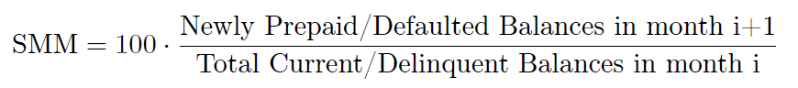
From SMM for prepay and default, we can generate the CDR curve and CPR curve as below.
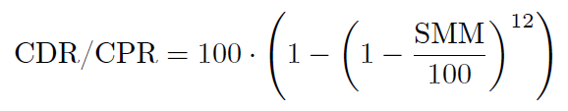
- Logistic Regression
We used logistic regression in our balances forecast. We will start from our cleaned data as described above. Since we have 4 statuses to forecast, we will need to run 4 regressions.
- Dependent variables
Our dependent variable will be include
- All Bucketized loan-specific variables as described in section 2(d).
- Loan Age
- Macro-Economic variables
- Loan Current status: ‘Current’ or ‘Delinquent’

- Transition Probability Matrix
We are essentially estimating the following transition probability matrix from the historical payments pattern.
 |  | Forecast Payment Status
 |  | Current | Delinquent | Prepay | Default
Current Payment Status | Current | y | y | y | y
Current Payment Status | Delinquent | y | y | y | y
Current Payment Status | Prepay | 0 | 0 | 1 | 0
Current Payment Status | Default | 0 | 0 | 0 | 1

If a loan is ‘Current’ or ‘Delinquent’ this month, it may goes to each of the 4 statuses in the following month.
If a loan is ‘Prepaid’ or ‘Defaulted’ this month, we consider those 2 statuses as absorbing statuses and it will stay in that status forever.

- Independent variables
An indicator will need to be added as the dependent variable. This represents probability of going to each status in the forecast.
Take the same example in section 2(e), this loan
loan ID | Origination Date | payment string | Status | Age
1234 | 01/29/2018 | CCCCP | C | 1
1234 | 01/29/2018 | CCCCP | C | 2
1234 | 01/29/2018 | CCCCP | C | 3
1234 | 01/29/2018 | CCCCP | C | 4
1234 | 01/29/2018 | CCCCP | P | 5

Will become
loan ID | Origination Date | payment string | Status | Age | Indicator (Current) | Indicator (Delinquent) | Indicator (Prepay) | Indicator (Default)
1234 | 01/29/2018 | CCCCP | C | 1 | 1 | 0 | 0 | 0
1234 | 01/29/2018 | CCCCP | C | 2 | 1 | 0 | 0 | 0
1234 | 01/29/2018 | CCCCP | C | 3 | 1 | 0 | 0 | 0
1234 | 01/29/2018 | CCCCP | C | 4 | 0 | 0 | 1 | 0
1234 | 01/29/2018 | CCCCP | P | 5 | 0 | 0 | 1 | 0

This loan was paid full in the first 4 months went default in month 5. We will need to have indicator for each of the 4 statuses. This indicator is essentially whether it will transit to the status in the next month.
For ‘Indicator for Current’, the loan will stay ‘Current’ for the first 4 months, hence for first 3 months, the transition indicator to Current will be 1. For month 4, as it will transit to ‘prepay’ in month 5, the indicator to Current will be 0.
After we have built the four indicator columns, we will run 4 logistic regressions to calculate the probability for the transition probability matrix.

- Portfolio Balances Forecast
We take the current snapshot of the portfolios and use that as the starting balances for ‘Current’ and ‘Delinquent’ statues because those balances are active. We set the ‘Default’ and ‘Prepay’ starting balances to 0 as all the defaulted and prepaid balances will stay in that status and will not contribute to the portfolio balances changes.

- Regressor Combination in each time period
In our model, two loans with same independent variables will have the same probability going to each of the four statuses. So to simplify the calculation, we will group those loans together and treat them as one single loan. E.g,
loan ID | PTI [0, 0.05) | PTI [0.05, 0.1) | PTI [01, 0.15) | PTI [0.15+) | Age 1 | Age 2 | Age 3 | … | Status | Loan Balance
1 | 0 | 1 | 0 | 0 | 1 | 0 | 0 | … | C | 1000
2 | 0 | 1 | 0 | 0 | 1 | 0 | 0 | … | C | 2000
3 | 1 | 0 | 0 | 0 | 0 | 1 | 0 | … | C | 5000

Will become
Regressor Combination | PTI [0, 0.05) | PTI [0.05, 0.1) | PTI [01, 0.15) | PTI [0.15+) | Age 1 | Age 2 | Age 3 | … | Status | Loan Balance
1 | 0 | 1 | 0 | 0 | 1 | 0 | 0 | … | C | 3000
2 | 0 | 1 | 0 | 0 | 0 | 1 | 0 | … | C | 5000

- Loan Age evolvement in each time period
At the next time period, all loan combinations will grow the age by 1 and some of the loans will go to age bucket [24 and above]. And hence at each time period we will need to regroup all the loans into new Regressor Combinations and get the new combination balances for next period forecast.
The same example as show above in the next forecast period will be different from the last time step. It will become below before regrouping:
Regressor Combination | PTI [0, 0.05) | PTI [0.05, 0.1) | PTI [01, 0.15) | PTI [0.15+) | Age 1 | Age 2 | Age 3 | … | Status | Loan Balance
1 | 0 | 1 | 0 | 0 | 0 | 1 | 0 | … | C | New Balance
2 | 0 | 1 | 0 | 0 | 0 | 0 | 1 | … | C | New balance

- Results:
- Portfolio Balances Forecast
Our forecast for the portfolio balances in the forecast period based on the current portfolio snapshot balances is as below

“Current” Balances:
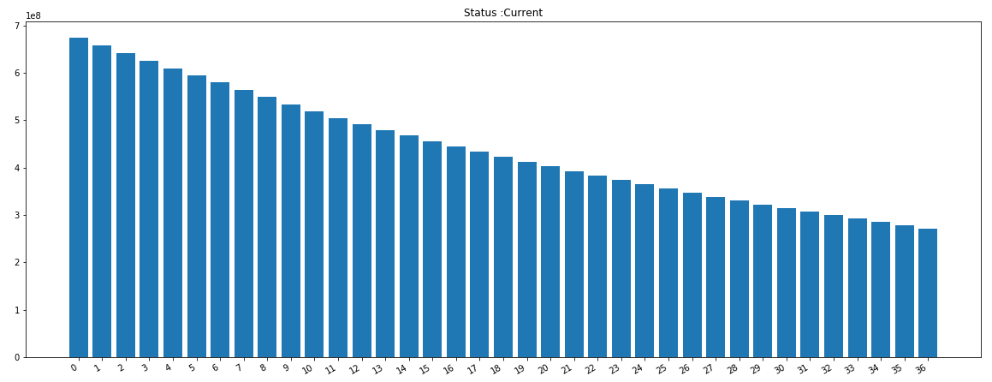
“Default” Balances:
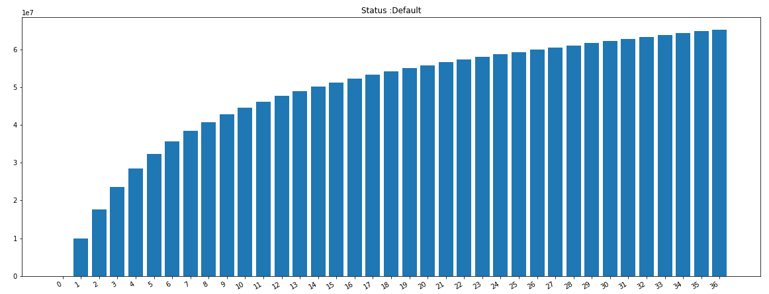
“Delinquent” Balances:
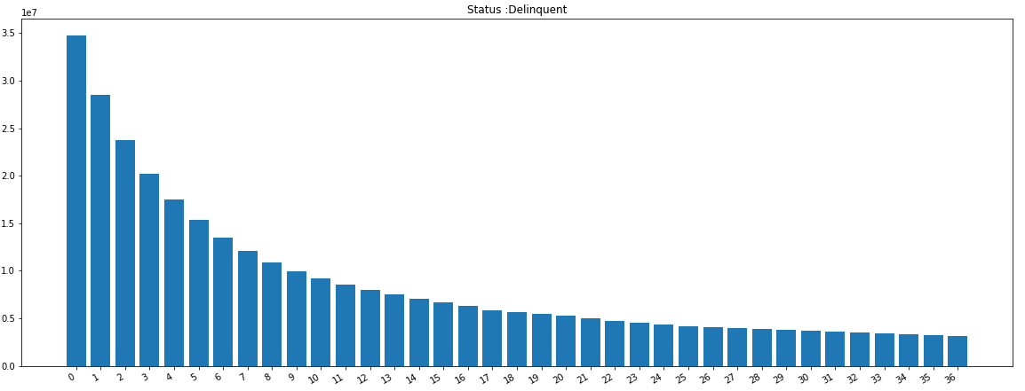

- CDR and CPR Curve
CDR:
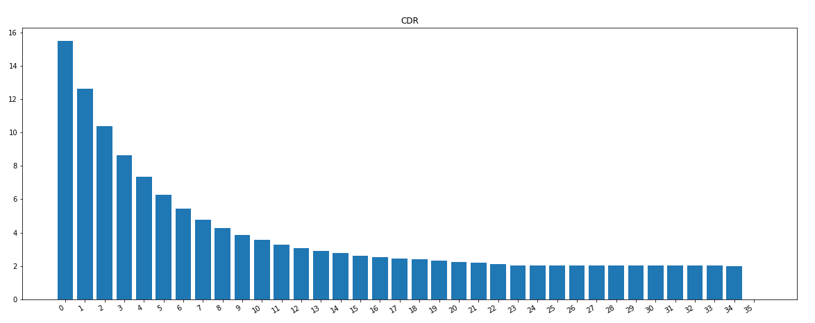
CPR: 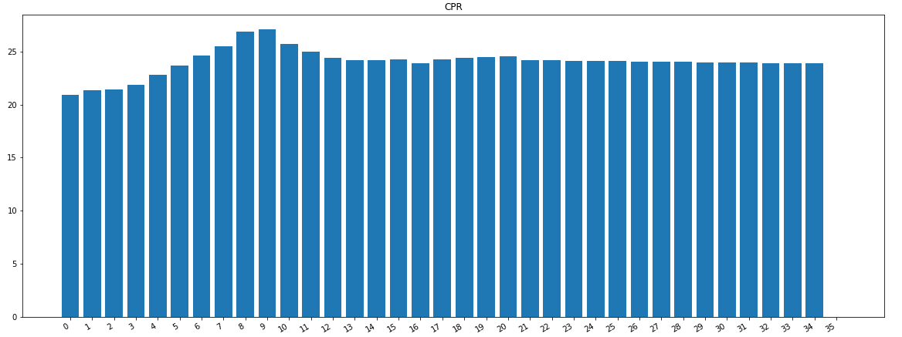

- Further Improvements:
This work could be applied to all structured credit products such as credit card loans, car loans, mortgages and etc because essentially those products only differ in the underlying.

- More Loan Status:
Currently we have 4 categories for each the loans (‘Current’, ‘Delinquent’, ‘Prepaid’, ‘Defaulted’). We could further divide the delinquent into “30 – 59 Days Delinquent”, “60 – 90 Days Delinquent” and so on.
This also means we need a large transition probability matrix as below:
 |  | Forecast Payment Status
 |  | Current | 30-59 Days Delinquent | 60 – 90 Days Delinquent | Prepay | Default
Current Payment Status | Current | y | y | y | y | y
Current Payment Status | 30-59 Days Delinquent | y | y | y | y | y
Current Payment Status | 60 – 90 Days Delinquent | y | y | y | y | y
Current Payment Status | Prepay | 0 | 0 | 0 | 1 | 0
 | Default | 0 | 0 | 0 | 0 | 1

- More macro-economic variables:
We have looked at the 3 year swap rates and unemployment rates. 3 year swap rates are not significant in forecasting the probability matrix and unemployment rates needs more justification in the economic cycles. If the economic situation will stay stable in the forecast period, we could apply the unemployment but if there are regime changes in macro-economic environment, the relationship between the probability and unemployment can be reversed.

